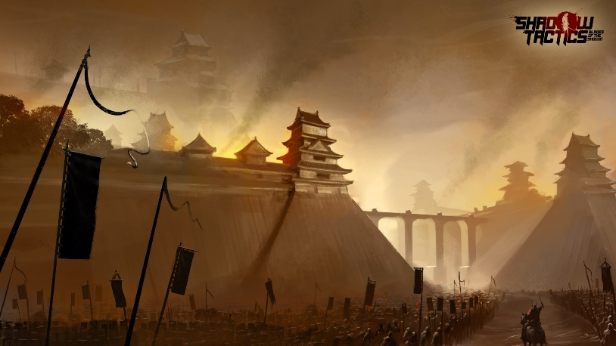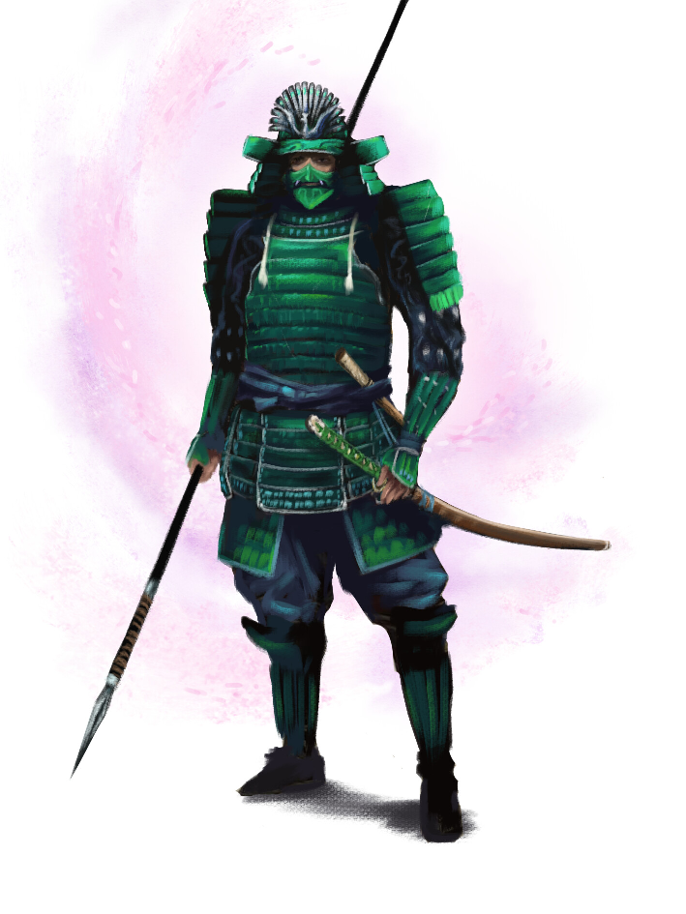

A Warring State

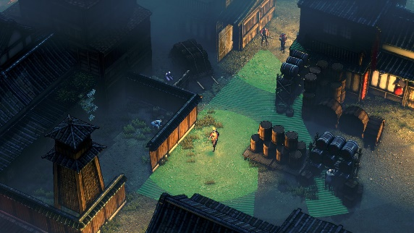

**External Goals:**

* Creating a portfolio piece
* Creating an interesting mix of strategy, Card-Game and souls-like elements
  + Advance level- & game-design knowledge
* Getting familiar with UE4

Gameplay Goals:

* Player has to find a way through levels fitting their play-style
* Dealing with the random order

of available Abilities as well as the pros and cons that come along with them

Story

It’s the Sengoku Jidai – the period of warring states. A time where the fate of once mighty clans can change within days, a time of great self-sacrifices and bravery but also of treachery and betrayal.

The Player follows the Story of Hattori Hanzo, who is a loyal servant of Tokugawa Ieyasu. While fighting for the values of honor and loyalty that he grew up to the character will soon face many wars, not just around him, but within as well…

**Target audience:**

* fans of round-based strategy

like Divinity Original Sin, Desperados, Gears Tactics, XCOM

* 16+ years old
* fans of Japanese history